Lab Assignment 9
Stepan Shkrobak
Dr. Michael Bartolacci
IST 894, Section 001: Capstone Experience,
29 March 2026

Table of Contents

Table of Contents 1
General Context 2
Technical Context 3
Screenshots 5
References 6

General Context
The course Digital Evidence and Legal Issues covered how technical work becomes usable evidence in an investigation. The most emphasis and importance is placed on the handling of evidence to preserve its integrity, authenticity, and traceability, given how easy it is to create, alter, copy, or delete electronic data. This means things like performing the proper technical preservation processes for imaging or extracting data, documenting every step, and maintaining a chain of custody for the evidence items. This is even mentioned in NIST, where it is noted that preserving digital evidence presents challenges beyond traditional evidence preservation, and from the National Institute of Justice, which emphasizes identifying, collecting, preserving, and safeguarding digital evidence so it remains useful in court. Failing to properly handle or preserve evidence could result in it being rendered unusable in court and getting thrown out, and the potential evidence it had can no longer be used in court.
The course also went over that investigators cannot simply collect anything they find and assume it is usable. There are laws, regulations, and policies in place that must be considered, whether by law enforcement, IT, or management. Things like warrant scope, consent, privacy expectations, provider-held records, and distinction between content and non-content records all need to be understood and considered before collecting digital evidence. This is also key because evidence can be excluded when collection is improper, and any work done must also stay inside legal boundaries. The course lined up with the Federal Rules of Evidence, including Rule 901 on authentication, and NIJ guidance that admissible evidence must be authentic, in good condition, and able to withstand scrutiny about how it was collected and preserved.
Finally, a key skill that was emphasized was judgment. Investigators must consider broader aspects of digital evidence collection, like business impact, privacy, ethics, and expert responsibility. An employee could easily pull logs or images of company systems for their managers, executives, or departments for investigations, while investigators will require legal authority in addition to identifying what is needed because imaging, for example, a whole server is unrealistic depending on the size, so the scope must be identified, and the data collection must be reasonable. This also includes potentially taking into consideration the effects of evidence seizure or a search on dependent customers, for example, pharmacies or medical centers. Investigators must preserve data correctly, stay within authority, document decisions, and present conclusions that can survive review. That is also consistent with the broader professional view that digital forensics supports both criminal and internal policy investigations, while expert testimony and evidence handling are judged on reliability and defensibility, not just technical competence.

Technical Context
The Digital Evidence and Legal Issues course focused on evidentiary reliability, forensic soundness, and defensible data handling rather than the simple collection of evidence. From a technical information security perspective, one of the primary skill areas in the lab was preservation of digital evidence in a manner that maintains integrity, provenance, and later admissibility. Because electronic evidence can be altered by user activity, operating system processes, remote access, or collection activity itself, investigators have to think in terms of acquisition conditions, validation, repeatability, and documentation. This is why the broader technical focus of the lab was on issues such as chain of custody, integrity verification, acquisition methodology, and artifact authenticity, rather than merely obtaining access to data. NIST SP 800-86 describes digital forensics from an IT and incident-response perspective and emphasizes effective forensic processes across files, operating systems, network traffic, and applications, while SWGDE best practices similarly frame forensic acquisition around preserving evidentiary quality and reducing unnecessary alteration of source data.
Its secondary focus was lawful and procedurally correct acquisition. This means understanding that technical access does not equal investigative authority. It covered legal scope, consent, privacy expectations, provider-held records, and the distinction between content and non-content data, all of which affect what can be acquired, how it can be acquired, and whether the resulting evidence is usable. In technical terms, this is a control problem involving authorization boundaries, collection scope, and evidentiary authentication. Logs, communications, disk images, and provider records are only useful if they can be tied to a lawful collection basis and later authenticated as what the investigator claims they are. That aligns with Federal Rule of Evidence 901, which requires evidence to be supported by enough proof to show that an item is what its proponent claims, and with NIJ guidance that agencies need defined policies and procedures for the collection, handling, and processing of digital evidence

Finally there is investigative judgment where forensic, operational, and legal concerns all interact. Evidence collection has to be technically sufficient but also proportional, minimally disruptive, and appropriately scoped to the investigative objective. That means considering whether a full system image, targeted logical acquisition, record request, or other collection approach is justified relative to the evidentiary need and the operational impact on dependent users, services, or customers. This is especially important in enterprise environments where systems may be large, shared, business-critical, or contain intermingled protected data. The course also tied this to ethics and expert responsibility, reinforcing that investigators must distinguish factual observations from analytical conclusions, avoid overstating findings, and rely on methods that are reliable and reviewable.

Screenshots
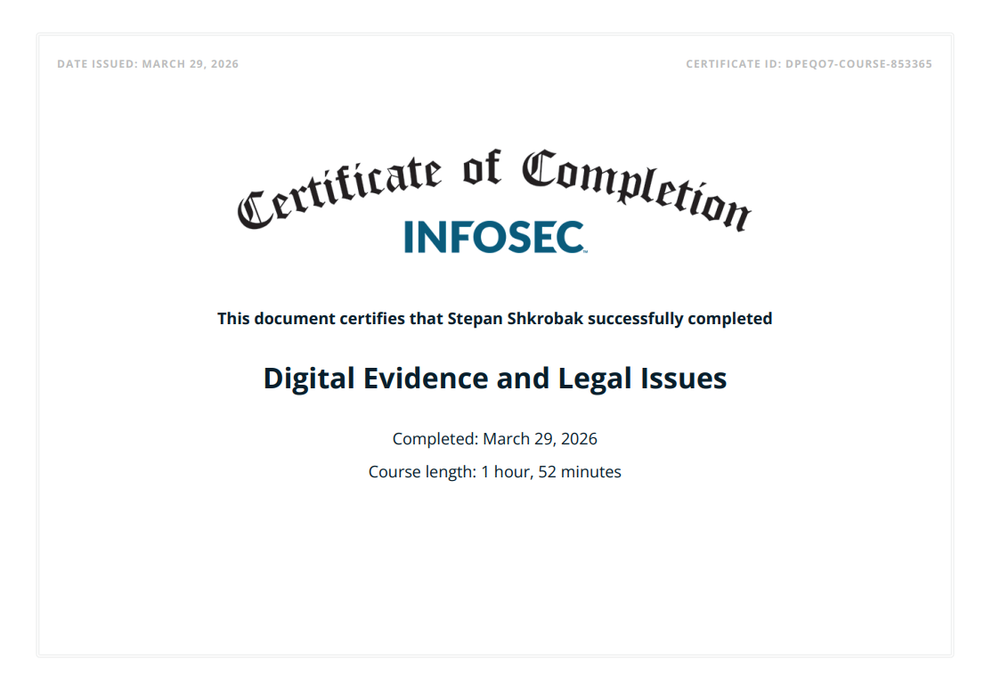

References
NIST SP 800-86, Guide to Integrating Forensic Techniques into Incident Response https://csrc.nist.gov/pubs/sp/800/86/final
National Institute of Justice, Digital Evidence Policies and Procedures Manual https://nij.ojp.gov/library/publications/digital-evidence-policies-and-procedures-manual
SWGDE, Best Practices for Computer Forensic Acquisition https://www.swgde.org/documents/published-complete-listing/17-f-002-2-1/
Federal Rule of Evidence 901, Legal Information Institute https://www.law.cornell.edu/rules/fre/rule_901

